EENG 385 - Electronic Devices and Circuits

Frequency Domain: Active Filters

How To: Setup the Level Shifter

**The Level Shifter**

Sometimes the audio signal input to your audio board will have no DC bias – it is centered around 0V. This means that the audio waveform spends ½ its time below 0V and will be clipped because our op amp is powered with 5V and GND. Thus, I included a level shifter whose schematic is shown in Figure 1. The level-shifter removes any DC bias from the input AC signal by the capacitor C1 and then adds a DC bias to this AC input using the voltage set by 100k potentiometer R1.

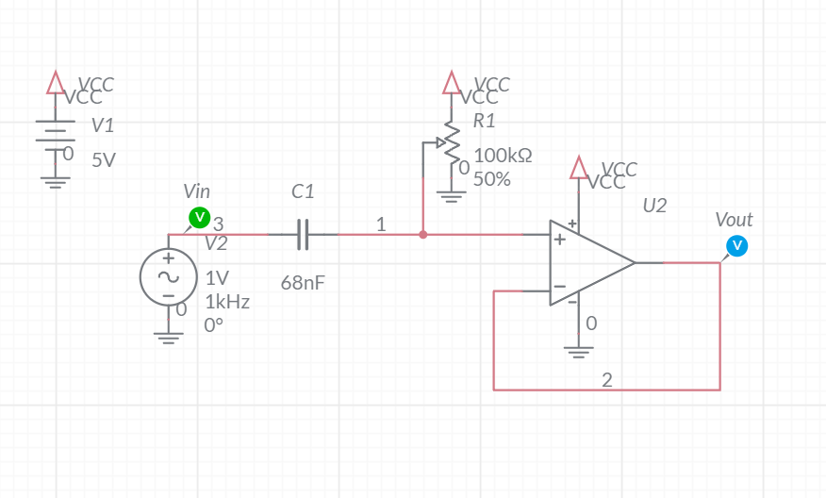

Figure 1: The level-shifter AC couples a signal onto a DC bias set by the potentiometer.

**How to: Setup the Level-Shifter**

The first step in tuning your level shifter is to properly setup the function generator output. A little extra time spent here will save you time later.

**Step 1: Setup test and measurement equipment**

The procedure to setup the function generator is given in list below. Each step is lettered A…K to correspond to letters in Figure 2.

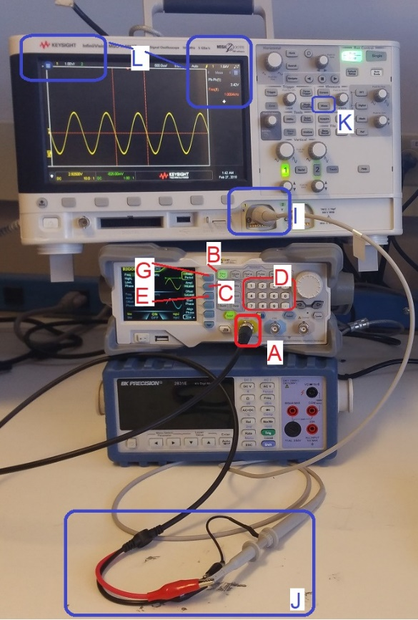

Figure 2: The test and measurement setup to check the signal input. Please DO NOT stack the equipment as pictured – this was done to fit all the equipment in one picture.

In the following procedure, dedicated keys are denoted with bold text in square brackets. Softkey are shown highlighted.

1. Connect a proper signal generator cable to the yellow BNC connector labeled "CH1" on the Rigol DG1022Z function generator. Insert firmly and twist until you feel it click. Give it a tug to make sure the BNC connector is securely mated,
2. If the **[Sine]** function key is not illuminated, press to illuminate it,
3. Press the Ampl/HiLevel softkey to highlight "HiLevel",
4. Enter 4.0 on the numeric keypad, and then press the Vpp softkey
5. Press the Offset/LoLevel softkey to highlight “LoLevel,
6. Enter 1.0 on the numeric keypad, and then press the Vpp softkey
7. Press the Freq/Period softkey to highlight “Freq”,
8. Enter 1.0 on the numeric keypad, and then press the kHz softkey
9. Connect a proper oscilloscope probe to the channel 1 input of the oscilloscope. Adjust the vertical scale to 1V/div and the horizontal scale to 500us, make sure that channel 1 is DC coupled, and that the trigger level is around 2.5V,
10. Connect the function generator and oscilloscope cables, black clip to black clip and red clip to scope probe,
11. Enable the function generator off by pressing the **[OUTPUT]** key,
12. Adjust the scopes so that they display frequency and the peak-to-peak amplitude of the waveform.
    * **[Meas]** → Clear Meas → Clear All
    * **[Meas]** → Source → 1
    * **[Meas]** → Type → Peak-Peak → Add Measurement
    * **[Meas]** → Type → Freq
    * **[↑ Back]**

Once complete, you should see the waveform on the oscilloscope oscillating around 2.5V.

**Step 2: Apply signal to the level shifter and measure input/output**

You are now going to use the function generator to send a sin waves into the LEVEL input and measure the DC offset of the output waveform.

* Install female end of a male/female jumper wire onto the INPUT LEVEL pin,
* Install female end of a male/female jumper wire onto the OUTPUT LEVEL pin,
* Attach the black ground clip of the function generator to a ground loop on the Audio board,
* Attach the black ground clip of the oscilloscope probe to a ground loop on the Audio board,
* Configure your oscilloscope,

|  |  |
| --- | --- |
| Horizontal (scale) | 1ms |
| Ch1 probe | INPUT LEVEL (male end of jumper wire) |
| Ch1 (scale) | 1V/div |
| Ch1 (coupling) | DC |
| Ch2 probe | OUTPUT LEVEL (male end of jumper wire) |
| Ch2 (scale) | 1V/div |
| Ch2 (coupling) | DC |
| Trigger source | 2 |
| Trigger slope | ↑ |
| Trigger level | 2.5V |

* Attach the red signal clip of the function generator to male end of jumper wire attached to the INPUT LEVEL jumper wire,
* Verify that everything is setup correctly by comparing your setup to Figure 3,

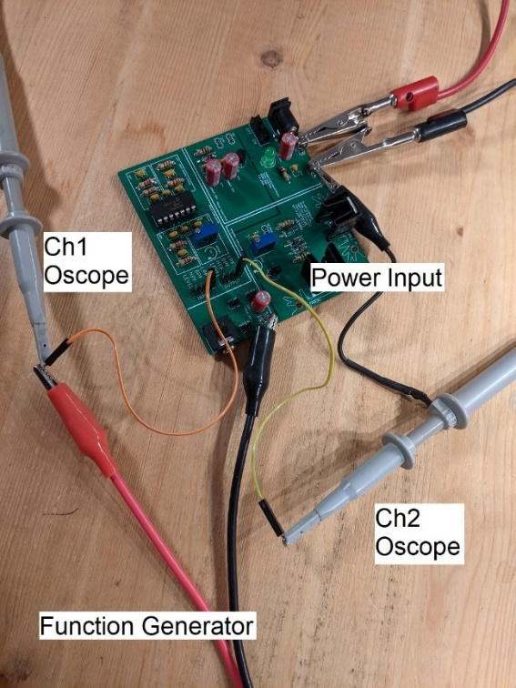

Figure 3: The setup to apply a signal to the LEVEL_IN and measure the response on the oscilloscope. Note the jumper wires are INCORRECTLY connected to the LPF header in this picture, because it’s the only picture I had lying around.

* Enable the function generator output
* Observe the oscilloscope, adjust the 100k POT until the output waveform is centered to 2.5V. As an example, the input in Figure 4 is coming in on channel 1 (yellow trace) and the level-shifted output is on channel 2 (green trace).

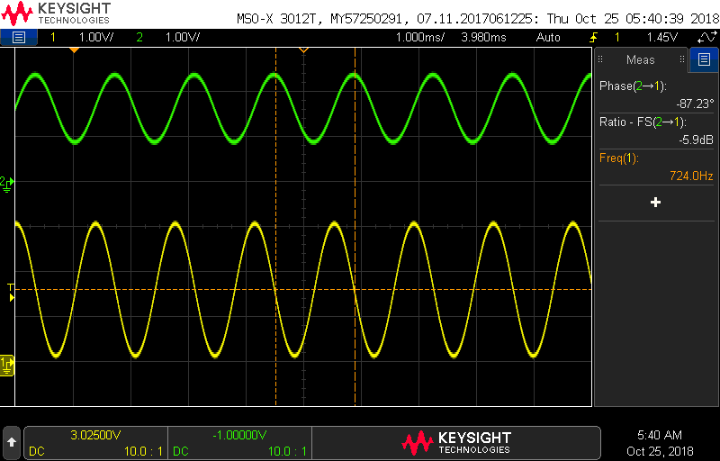

Figure 4: The input and output of the low-pass filter.

You are now ready to use the level-shifter to support Frequency Response Analysis function of the Keysight oscilloscopes.